**2D or not 2D?**

**That is the 2023 CROP ART question!**

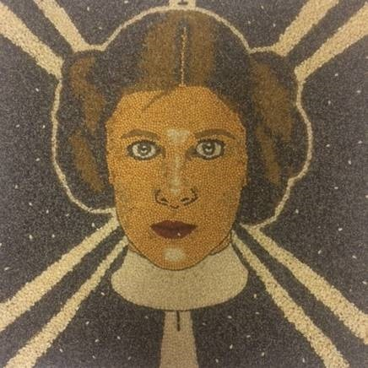

It’s been twenty-one lucky years since the traditional **Crop Art** competition got under way and fourteen for **3D Crop Art**. The traditional **Crop Art** contest is for flat or 2D entries. These are pieces that could be hung on a wall. The 3D competition adds another dimension to the contest. These 3D entries are more like a sculpture that would sit on a table.

**The Rules: Traditional Crop Art**

This contest calls for entrants to create a piece of artwork entirely out of dry seeds and beans. Entries in this category would include but are not limited to portraits, landscapes, and other pictures that would normally be painted. Submitted artwork will be judged on overall artistic merit, cleverness of subject, technique, originality, and skill. The natural color of the seeds and beans provides the only pigment to the pictures as no paint or dyes are allowed. Only seeds and beans that are used for crops that can be grown in Pennsylvania may be used. No portion of the seedpod is to be used in the artwork. The artwork is to be completely and exclusively created from whole and unadulterated naturally colored seeds and beans. Seeds should be affixed permanently to the flat surface with a clear or invisible adhesive. A clear protective finish may be applied. Seed portion of artwork must be less than ¾” thick. (If work is mounted on ½” thick board the total thickness of entry must be less than 1 ¼’.) Seeds may be layered or partially layered on top of one another as long as the total thickness doesn’t exceed ¾”. Crop Art pictures are to be no larger than 400 square inches in area and mounted on a stiff flat board such as plywood. It is not necessary that the board be rectangular. Pictures may have frames but frames are not required. No portion of mounting board is to be visible. Mounting board must be completely covered with seeds. There should not be glass or plastic covering the artwork. An unsigned 4” by 6” legend card must accompany the artwork with title and samples of the seeds used in the artwork clearly and neatly identified.

**The Rules: Crop Art 3D**

Entries in this category are to be three-dimensional sculptures of whatever support material is chosen covered entirely with dry seeds and/or beans. Clay, foam, natural or manmade objects may be used as the base material but no portion of this base is to be visible. No glue or supports are to be visible. Entire work must be covered with seeds so no props can be used. Work should be displayed on a board or support that is also completely covered with seeds. Entire installation must fit on a 12” deep shelf and no higher or wider than 24”. Submitted artwork will be judged on overall artistic merit, cleverness of subject, technique, originality, and skill. The natural color of the seeds and beans provides the only pigment to the pictures as no paint or dyes are allowed. A clear protective finish may be applied. Only seeds and beans that are used for crops that can be grown in Pennsylvania may be used. No portion of the seedpod is to be used in the artwork. An unsigned 4” by 6” legend card must accompany the artwork with title and samples of the seeds used in the artwork clearly identified.

Prizes for the contest are as follows:

18 Years and Older -First prize- $100, Second prize- $75, and Third prize- $50

10 to 17 Years Old- First prize- $50, Second prize- $40, and Third prize- $30

For more information on this competition call Paul Tucker

at 717-648-2971 or email at [pandktucker@comcast.net](mailto:pandktucker@comcast.net)

**Come visit and like our Dillsburg Farmers Fair Crop Art Page. Simply go to Facebook and type in Crop Art. See some of our past entries and get some inspiration for your own masterpiece!**

