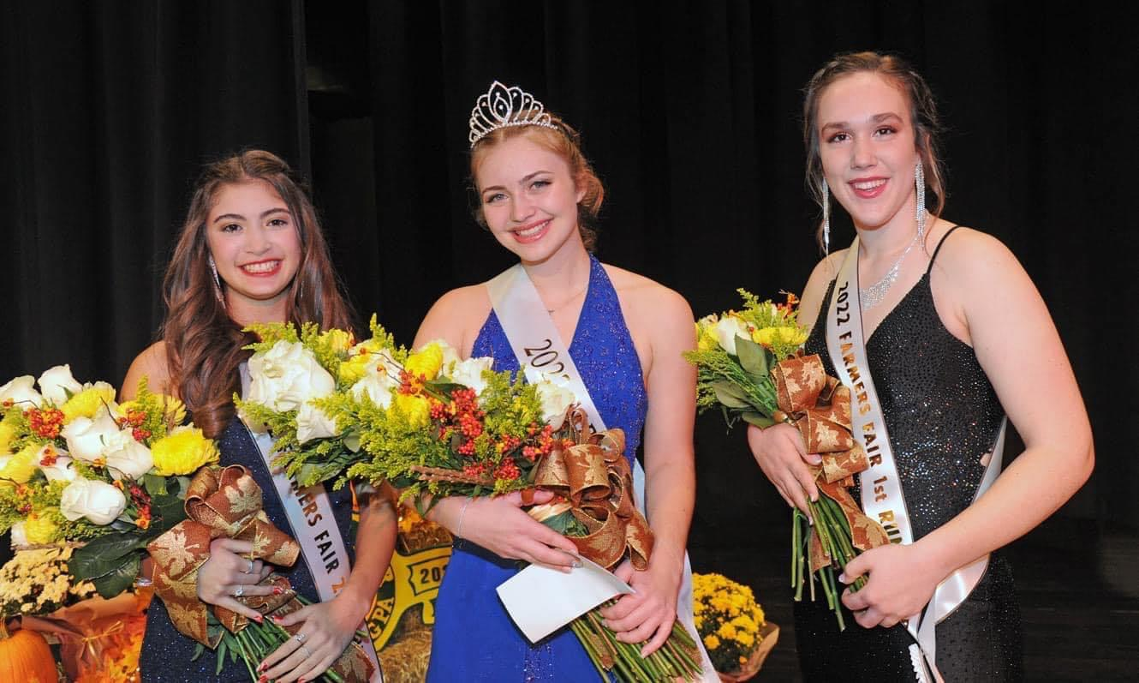

2nd Runner Up – Sophia Lobo (L)
1st Runner Up – Hailey Patterson (R)
Farmers Fair Queen – Penelope Brosius (C)

FARMERS FAIR 2023
67th Annual Queen Pageant
APPLICATION PACKET

Submit applications by email: FarmersFairQueen@gmail.com
September 8th: DEADLINE FOR SUBMITTING COMPLETED APPLICATION
For questions or concerns regarding the application process, please contact:
Farmers Fair Queen Pageant Committee: FarmersFairQueen@gmail.com

67th Annual Farmers Fair Queen Pageant

2023 FARMERS FAIR QUEEN PAGEANT
APPLICATION PACKET

We look forward to your participation in this year’s pageant! The following items are being transmitted to you in this packet:

Part 1: Reference Information
Pageant Rules, Judging Criteria, List of Obligations, Behavior Policy, Dress Code, Fair and Pageant Schedule (tentative)

Part 2: Application Instructions and Forms
Must be completed by computer using our official forms. Handwritten or re-formatted applications will be returned. Late entries (submitted after September 8, 2023 may not be eligible for participation. See instructions below. Complete forms in full and submit electronically. Print the OFFICIAL CONSENT TO PARTICIPATE (last page), sign and submit at our first meeting (or it may be scanned and submitted electronically).

Please include a recent photo for pageant publication and marketing purposes. This photo needs to be original, no filters or edits with a neutral or solid background. This does not need to be a professional headshot.

Part 1 – Reference Information

COMPETITION STRUCTURE AND DETAILS: The theme this year is "Community Connected through Agriculture”. You can be as creative with this as you wish. The possibilities are limitless. We are excited to see what you have in mind!

Each Contestant is expected to deliver a 5-minute presentation during the pageant. This presentation can be a speech, performance, or talent skit (or any combination of these). You may incorporate any talent. This could include dance, song, art, music, poetry, etc. You may use any appropriate music, DVD, CD, Power Point, or visual aid to enhance your presentation. However, your aid cannot BE your speech/talent. Please keep in mind that the judges are encouraged to consider that if your aid were to be taken away, would your time on stage be able to stand on its own. Note: the tech system is NOT Mac friendly. Please keep this in mind if using multimedia. Finalize all details and questions with a committee member before the night of rehearsal. Remember to keep your presentation to a MAXIMUM OF 5 MINUTES.
- All FINAL tech aid must be turned in by September 27. The Tech Crew needs time to make sure your flash drive, DVD, CD, etc. will work with their system. Please give this to a committee member or Mrs. Eshenaur in the Main Office no later than September 27, 2023. Please place it in an envelope or clear bag with: 1. Your Name and 2. "Farmers Fair Queen Pageant" clearly marked. Also, please INCLUDE ANY SPECIAL INSTRUCTIONS you may need (music stand, piano, or any props that you will be bringing for the stage crew).

Dress rehearsal will be from 9AM-2PM on Friday, October 13th in the Auditorium. Please meet at 9AM sharp – back stage. Pizza lunch will be provided for Contestants, stage crew, and tech crew. Escorts will rehearse with us for 1 hour from 9:30AM-10:30AM. The full name of your escort must be emailed to FarmersFairQueen@gmail.com by September 27, 2023. This is needed so that they may be excused for rehearsal. You may choose any male escort you wish. Practice will cover the entire event, please remember to bring your props and be ready with your speech or talent. Bring the shoes you plan to wear for the formal introduction portion of the evening so that you may practice walking on stage.
- This is our only rehearsal for the entire event, so it is imperative that you arrive READY and PREPARED. Please let your teachers know that you will be absent from class during this time. You are responsible to make arrangements to make up any class-work you will miss during rehearsal. However, if you have a class that you feel you MUST attend, you may do so. Please consult your parents and use your best judgment.

New Hope Ministries Donation Drive – Saturday, October 14th at 9AM at 99 W Church St, Dillsburg. More details to follow.

Formal Interviews & Luncheon – Saturday, October 14th at 10AM at The Quay House – 22 N. Baltimore St., Downtown Dillsburg. The luncheon will be provided by the Dillsburg Community Fair Association. Please dress professionally and appropriately, as you would for a professional job interview. At this breakfast, each Contestant will have an individual interview with our three judges. Upon completion of your interview, you may leave or feel free to hang around and mingle with the other Contestants.

Queen Pageant Day – Monday, October 16th
- You will need to be at the high school NO LATER than 6PM
- Enter through the doors on the Auditorium side. Go to Room 201 - this is the room that you will be able to get ready and change in throughout the evening. We provide chaperones to help you and to keep the area secure. Please note that family and friends are NOT allowed backstage, in Room 201, or any area in between where you located before or during the event.
- Each Contestant will need to appear in an evening gown (or formal) and ALSO in whatever you will need to wear to perform your speech / talent. Remember you are able to leave your things and change in Room 201.
- Judging is based on personality, appearance, poise and deliverance of performance.
- The Committee is not aware of the judge’s decisions. When you learn who wins, that is when we learn who wins!
- We understand that this is a contest, but please remember to have fun! If you are not crowned as Queen, please do not feel defeated. Just do your best. In many instances, the difference in scoring between Contestants is less than a point.
- You will be given 10 complimentary vouchers to give to family or friends. Tickets may be purchased at the door beginning at 6 PM for $5 (or $3 for students). Children 12 years of age or younger are free; however, they must be accompanied by an adult.

JUDGING CRITERIA:
- Written Essay - (300 words or less) Judging Criteria: content, grammar and spelling.
- Personal Interview - each Contestant will meet alone with the panel of 3 judges. Judging Criteria: conversational ability, the answers to the questions, appearance/poise, activities, and knowledge of the fair and our community.
- Individual Question – following the formal introduction on the night of the pageant each Contestant will be asked one question based off of their application details (interests, hobbies, job experience, etc.), our community, the fair, current theme/topic, etc. Judging Criteria: thoughtfulness, conciseness and overall poise as it pertains to answering the individual question.
- Speech/Talent Presentation on the topic "Community Connected through Agriculture" (3-5 minutes; timed event). Persuasive speech/talent appropriate for an audience of adults. The audience is the panel of 3 judges along with the parents, students, or guests of our community who are in attendance. Props that enhance this speech for this targeted audience are permitted, but not required. Contestants are judged on the effectiveness of their public speaking skills; not “entertainment”. Judging Criteria: speech content, speech format, conveying a message, public speaking ability, and poise/presence.
- Evening Gown/Introduction - conducted on stage in front of the audience (approx. 500 people) including the 3 Judges. Each Contestant’s personal bio will be read during their appearance. Judging Criteria: content, stage presence, and appearance.

RULES: Below are the Official Farmers Fair Queen Program rules.
Each Farmers Fair Queen Contestant must:
- Be a female living in the Northern York County School District
- Currently in grades 9 - 12
- Have not been a former Farmers Fair Queen winner
- Have her parent(s)' or guardian(s)' consent to enter the competition

FAIR QUEEN BEHAVIOR POLICY:
The Pageant’s governing Committee shall have the sole discretion to determine whether, in its judgment, the Queen, Alternate or Contestants may continue to participate in the pageant. The following will be considered violations of the Policy and will be grounds for immediate disqualification, dismissal and/or being banned from future Queen Competitions:
- Any infractions of any Queen Pageant rule.
- Smoking, drinking alcoholic beverages, foul language and/or public displays of affection to dates/boyfriends while wearing crown and/or sash and representing the Queen Program.
- Engagement in any illegal, unpartisan, unethical, indecent and/or morally questionable behavior, including but not limited to online representations on the Internet such as social networking sites (Facebook, Twitter, and Instagram).
- Use of any illegal controlled dangerous substances or abusing the use of alcohol or other dangerous substances.
- Any defamation of the Queen Pageant, its winners and Contestants, and the Farmers Fair or the Queen Program and their Directors and Committee members, whether it be oral or written. This includes postings on the Internet.
- Any uncooperative or unsportsmanlike conduct before, during or after the competition.

FAIR QUEEN DRESS CODE: Wearing of the Fair Queen crown and/or sash is to be considered an honor and privilege. The bearer is now an ambassador representing herself, her family, her community and Farmers Fair. While fashion styles may change, good taste does not!
Therefore responsible, appropriate and professional appearance is expected while the Queen is wearing her crown and sash:
- Attire that is conducive to the specific appearance or event (i.e. casual, business casual, formal, etc.)
- It is strongly recommended that closed toe shoes be worn when in livestock areas, for safety reasons.
- No outfit that shows cleavage.
- Dresses/skirts must be no shorter than the height of a dollar bill (approx. 2.5”) from the bottom of the dress/skirt hem to the top of the knee cap.
- No clothing that advertises, promotes, or glorifies the use of alcohol, tobacco, drugs, or anything inconsistent with the dignity of the Queen Program.

IMPORTANT DATES:
- Friday, September 8th – application deadline
- Wednesday, September 27th – all tech aid for pageant is due
- Friday, October 13th – 9AM - 2PM – Dress Rehearsal
- Saturday, October 14th
  - 9AM – Meet at New Hope Ministries for the Donation Drive
  - 10AM Formal Interviews & Luncheon at The Quay House
- Monday, October 16th – PAGEANT DAY
  - Arrive at NHS Auditorium no later than 6PM

*OBLIGATIONS: If selected as the new Farmers Fair Queen, the Queen and her court will be presented with upcoming Farmers Fair commitments as the week unfolds.
Part 2 – Application

The complete, signed original Application must be submitted by September 8th. Application packet must be completed using the official forms. Application Forms available online at www.dillsburgfarmersfair.org under the “Entry Forms” tab.
Handwritten or re-formatted applications will be returned. If emailed – please print signature pages or use an e-signature. Late entries may not be eligible for participation. The Farmers Fair Queen Pageant Committee reserves the right to refuse a Contestant’s eligibility if a complete Application is received after the September 8 deadline.

APPLICATION ITEM CHECKLIST
The following items to be submitted together:
- Application Form with signatures
- Short Biography for Program Booklet
- Biography Form for Judges
- Essay for Judging

September 8th: DEADLINE FOR SUBMITTING COMPLETED APPLICATION
For questions or concerns regarding the application process, please contact:
Farmers Fair Queen Pageant Committee: FarmersFairQueen@gmail.com

APPLICATION ITEM 1: Official 2023 Farmers Fair Queen Pageant Application

Name of Contestant: Enter your name Age: Enter your current age
Contestant’s Mailing Address: Enter mailing address
City: Enter City Zip: Enter Zip County: Enter County
Contact Number(s): Enter preferred contact number
Addition Contact Number(s): ____________________________

Parent/Guardian Contact Information: Name of Parent/Guardian
Contact Number(s): Enter preferred contact number
Addition Contact Number(s): ____________________________
Email Address: Enter preferred email

A committee member will contact you by phone/email to notify you of your application status for the 2023 Farmers Fair Queen Pageant.
APPLICATION ITEM 2: SHORT BIOGRAPHY For inclusion in the 2023 Farmers Fair Queen Pageant Program booklet

INSTRUCTIONS:
1. The Short Biography is a required part of the Application.
2. Handwritten not accepted.
3. Double-space, black ink only.

A sample is included below. Please keep paragraphs to this length. The Committee reserves the right to edit the biography paragraph to the proper size to fit beside the photo of the Contestant in the Program booklet.

Example of Biography:

Jane Doe –
Jane is the 17-year old daughter of John and Mary Doe of Dillsburg. She is an active member of the FFA, Student Council and she is the co-captain of the field hockey team. Her employment experiences include the Pickle Nickel, babysitting, and working at the Farmers Fair open-air market at St Paul’s Lutheran Church baked goods stand. Jane also serves as a volunteer at the Helen Krause Animal Shelter and Ski Roundtop Mountain Resort. In her free time, she enjoys skiing and snowboarding.

Enter Biography Here:

APPLICATION ITEM 3: BIOGRAPHY FOR JUDGES
2023 Farmers Fair Queen Pageant Biographical Information
All information will be reviewed by the Judges as part of the pageant judging process.
Name of Contestant: Enter your name Age: Enter your current age
HIGH SCHOOL SCHOLASTIC ACHIEVEMENTS, ACTIVITIES, HONORS, AWARDS: Scholastic Achievements, Activities, Honors, Awards | Leadership Position Held (if applicable) | Year
_______________ | _______________ | _______________
_______________ | _______________ | _______________
_______________ | _______________ | _______________
_______________ | _______________ | _______________
_______________ | _______________ | _______________
_______________ | _______________ | _______________
_______________ | _______________ | _______________
COLLEGE SCHOLASTIC ACHIEVEMENTS, ACTIVITIES, HONORS, AWARDS: Scholastic Achievements, Activities, Honors, Awards | Leadership Position Held (if applicable) | Year
_______________ | _______________ | _______________
_______________ | _______________ | _______________
_______________ | _______________ | _______________
_______________ | _______________ | _______________
_______________ | _______________ | _______________
_______________ | _______________ | _______________
_______________ | _______________ | _______________
PARTICIPATION IN FARMERS FAIR Describe Involvement, Activities, Awards, Ceremonies, Honors, Volunteering | Leadership Position Held (if applicable) | Year
_______________ | _______________ | _______________
_______________ | _______________ | _______________
_______________ | _______________ | _______________
_______________ | _______________ | _______________
_______________ | _______________ | _______________
_______________ | _______________ | _______________
_______________ | _______________ | _______________
COMMUNITY INVOLVEMENT List any Community, Church, Club Activities, Awards, Honors | Leadership Position Held (if applicable) | Year
_______________ | _______________ | _______________
_______________ | _______________ | _______________
_______________ | _______________ | _______________
_______________ | _______________ | _______________
_______________ | _______________ | _______________
_______________ | _______________ | _______________

HOBBIES/INTERESTS
_______________
_______________
_______________
_______________
_______________
_______________
_______________
EMPLOYMENT EXPERIENCE (if applicable)  List Place of Employment | Leadership Position Held (if applicable) | Year
_______________ | _______________ | _______________
_______________ | _______________ | _______________
_______________ | _______________ | _______________
_______________ | _______________ | _______________
_______________ | _______________ | _______________
_______________ | _______________ | _______________
_______________ | _______________ | _______________

WHY I WANT TO BE THE NEXT FARMERS FAIR QUEEN:
Enter why here _____________________________________________________________________

APPLICATION ITEM 4: ESSAY
“There is no other community as connected as
those in agriculture.” Ryan Goodman

Keeping this quote in mind, describe ways in which
this is demonstrated in our own community.

** This is a Judged Item **

INSTRUCTIONS:
- Word Count: The body of the Essay must be 300 words or less. This does not include the title
- The Essay must be typed or word processed on a separate sheet(s) of paper
- Page Margins: Normal
- Font Size: 12 pt
- Font Color: Black
- Double-space the Essay
- Include your name on the top right-hand corner of each page of the Essay
- Include total word count on the bottom right-hand corner of the page

JUDGING:
Content, Grammar, Spelling and Word Count (body of Essay must be 300 words or less)

Example:

Contestant: Jane Doe

Application Item 4: Essay
(Title here – if desired)

(insert essay text here, typed/word-processed, 1” margins on all sides, font size 12”, black print and double-spaced)

Essay Word Count: 290

OFFICIAL CONSENT TO PARTICIPATE: 2023 Farmers Fair Queen Pageant

“I hereby acknowledge that the personal information provided on this Application is truthful and correct. I have received, read, and understand the entire Application Packet (Part 1 – Reference Information and Part 2 – Application Instructions and Forms). I have completed the entire application by computer, it is not hand-written, and is being submitted as a whole. I hereby agree to abide by the Farmers Fair Queen Program Official Rules and Regulations pertaining to the pageant as listed in said Application Packet.”

SIGN BELOW AFTER PRINTING COMPLETED APPLICATION: Then submit this portion to a committee member.

____________________________________________ Farmers Fair Queen Contestant’s Name

____________________________________________ Farmers Fair Queen Contestant’s Signature

____________________________________________ Date of Signatures

Parent/Guardian: I understand that as a Contestant, photos of my daughter may be taken by Farmers Fair Photographers and/or the Dillsburg Banner. These photos will/may be used for the promotion and celebration of our Fair and may be archived for future reference.
Please note that only authorized persons will be allowed backstage or beyond the Auditorium on the night of the pageant. The fair has positioned numerous marked and unmarked security officers outside and inside the pageant event.

____________________________________________ Parent/Guardian Signature

____________________________________________ Date of Signatures

